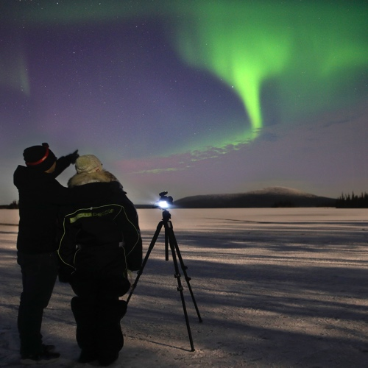

Aurora Chase™
September - April 20:00- 24:00 *

Change the way you think about ‘space’, the universe and our environment using photography. Chase the Northern Lights under the Arctic night skies. Aurora Chase is more than an aurora tour.

Discover your creativity and inner photographer and have fun with Arctic Frontier. We share our skills in photography, knowledge of the local environment and our equipment to find new ways to explore night photography in our amazing environment.

Whilst waiting for the aurora we ‘play’ with our cameras, taking selfies, groupies, light painting and learning simple ways to enhance your photographs.

The darkness of the Arctic night provides a place for a sense of freedom, and we invite you to capture this with us.

The photographs and memory card are yours to keep.

All equipment is provided and no prior photography experience needed. Or bring along your own camera. We'll show you how the rhythms of the aurora are enhanced with a few simple camera techniques.**

Departing nightly, Arctic Frontier provides small groups with a safe and comfortable experience.

Arctic Frontier offers access to Nikon SLR digital cameras, Manfrotto tripod, Arctic Overalls and winter boots, professional instruction and head torches.

Max. group size: 8 people. Private experiences can be arranged.
Suitable for 12+ years, ideal for teenagers!
Approximately 4 hours.

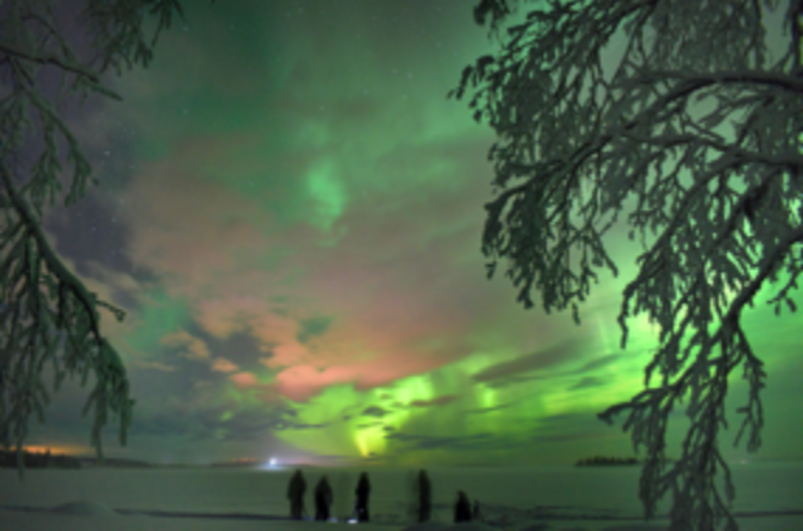 | Arctic Frontier provides access to:  Nikon SLR digital camera  Manfrotto tripod  Arctic overalls  Professional instruction  Warm and comfortable transport  Head torch  Chocolate brownies  Home-made wild berry juice

*The Chase can be extended past midnight if conditions are suitable. Alternative times are also available to coincide with the best aurora and weather forecasts.
** Like the weather, we have no control over the northern lights, and cannot guarantee their visibility. However, with our support and equipment your chances of an aurora encounter are increased significantly.

www.arcticfrontier.fi
mail@arcticfrontier.fi
+358 466 596443 & +358 466 148 543

