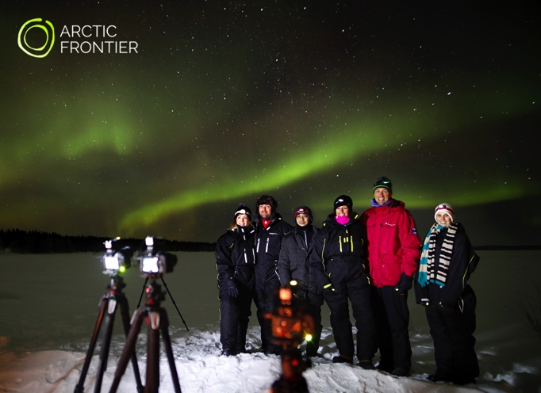

Aurora Chase
December 2018 – April 2019
Nightly 20.00 - 24.00*

Capture extraordinary memories that last a lifetime and take your own photographs of the Northern Lights! Join us for an exciting journey where we chase the aurora in comfort and warmth.

We share our knowledge in aurora photography and take you to the places where you have the greatest chances of seeing the Northern Lights.

All equipment is provided and no prior photography experience needed. We'll show you how the rhythms of the aurora are enhanced with a few simple camera techniques.

Departing nightly from Levi, Finland, we provide small groups with a safe and comfortable Arctic experience. The photographs and memory card are yours to keep. **

Departure point and return: Zero Point, Levi.
Price: 180€
Max. group size: 8. (suitable for ages 12+)

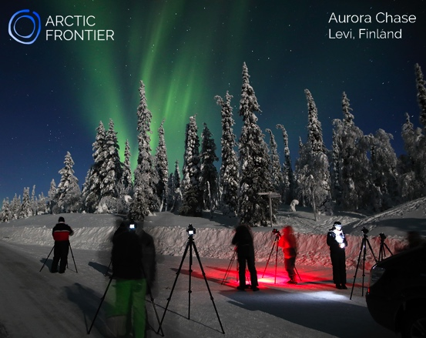 | Arctic Frontier provides access to:  Nikon SLR digital camera  Manfrotto tripod  Arctic overalls  Professional instruction  Warm and comfortable transport  Head torch  Chocolate brownies  Home-made berry juice

*The Chase can be extended past midnight if conditions are suitable. Alternative times are also available to coincide with the best aurora and weather forecasts.
** Like the weather, we have no control over the northern lights, and cannot guarantee their visibility. However, with our support and equipment your chances of an aurora encounter are increased significantly.

www.arcticfrontier.fi
mail@arcticfrontier.fi
+358 466 596443

