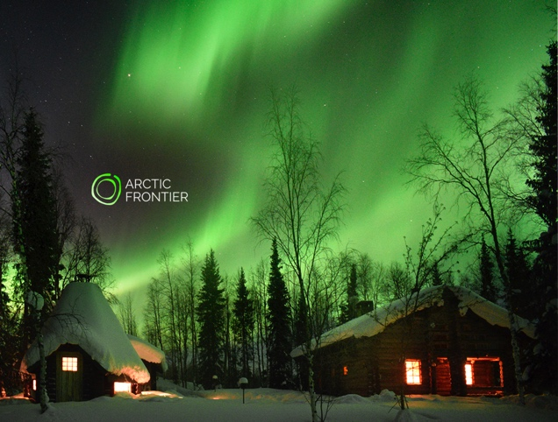

Aurora Chase Deluxe
Arctic Food & Photography

Journey to the private shores of an Arctic lake and enjoy wide-open views of the northern night sky, in your exclusive log cabin. Share a meal, cooked with love, next to a fire and discover how to photograph the beauty of Lapland.

The Arctic Frontier cabin, located metres from a lake, is nestled between the fells of the National Park. View the Arctic skies by the lakeside fire or retreat to your own traditional Finnish log cottage, with modern facilities to see the aurora in warmth and comfort.*

We provide you with high quality camera equipment and show you how the rhythms of the aurora are enhanced with a few simple camera techniques. Professional landscape photographer, Dr. Juha Tolonen, shares his skills to guide you to take your own photographs in the beautiful Arctic environment.

The evening begins with a meal in the cabin prepared for you from quality
Arctic produce. See menu attached. While you wait for the aurora, enjoy our famous dark chocolate brownies and warm homemade berry juice by the fire in a private Lapland style hut.

No prior photography experience is needed. Nikon cameras, Manfrotto tripods and memory cards are provided. The memory card is yours to keep.

We will use the Arctic Frontier van to ‘Chase’ the gaps in the clouds if required to increase your chances of seeing the aurora.

Pick-up and return from accommodation. 35km journey to cottage from Levi.
Duration: 4 hours (or by arrangement).
Package 1400€ for two, additional 100€ per person & 50€ per child (under 15) max 8 pax

* The auroras are a natural phenomenon and cannot be guaranteed. We provide you with the best opportunity to view the aurora on any given night. You will also learn many night photography and light painting techniques during the evening.

www.arcticfrontier.fi
mail@arcticfrontier.fi
+358 466 596443

ARCTIC FRONTIER DINNER MENU

Experience the beauty and uniqueness of the Arctic environment through our food.

Our Aurora Chase Deluxe meal is sourced from quality local Arctic ingredients, which are both farmed and foraged. Growing in the cleanest air in Europe, collected ethically and sustainably.

Slow Cooked Local Reindeer in Beer & Juniper
Slow cooked reindeer in dark beer from Tornio, with local wild mushrooms, prunes and juniper berries from Levi fell. Served with homemade lingonberry jam & pickled cucumber.

Puikulaperuna - Christmas Potatoes
Christmas puikula potatoes (‘imellettyyn perunalaatikkoon’). Lapland’s special potatoes slow cooked for at least 3 hours, made with Aunty Sanelma’s recipe.

Something Green & Crunchy
A 'seasonal' green salad - using ingredients that are fresh, crunchy and green.

GIngerbread & Lingonbery Icecream
The flavours of Christmas! Gingerbread and lingonberry ice-cream, with bursts of cranberries from the wetlands near Levi. We make you dig in the snow for your dessert! Shovels are provided.

Non alcoholic drinks are included in your meal, but please feel free bring your own wine, beer or spirits.

Children in your group? We’ll include a Finnish version of 'cheesy mac' or 'cheesy pasta'. Loved by children all over Finland (especially tasty with tomato sauce)!

We do not use pork products in our food. Other dietary requirements can be easily accommodated. Please contact us in advance.

www.arcticfrontier.fi
mail@arcticfrontier.fi
+358 466 596443

