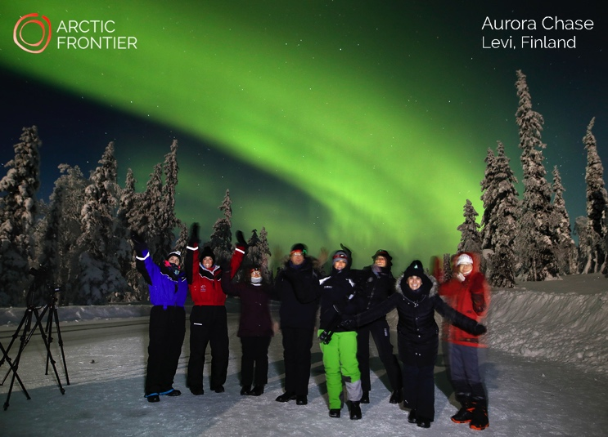

Exclusive Aurora Chase
October 2018 – April 2019
20.00h - 24.00h*

Capture extraordinary memories that last a lifetime and take your own photographs of the Northern Lights! Join Arctic Frontier for an exciting journey to chase the aurora in comfort and warmth, tailored to your needs.

We share our knowledge in aurora and night photography, using high quality, easy to use equipment. Taking you to places where you have the greatest chances of seeing the Northern Lights in the beautiful Arctic environment.

All equipment is provided and no prior photography experience needed. We'll show you how the rhythms of the aurora are enhanced with a few simple camera techniques. Take your own groupies under the Arctic skies!

Our Private Aurora Chase provides small groups and families, with a safe and comfortable Arctic experience. The photographs and memory cards are yours to keep. **

Departure point and return: Zero Point, Levi.
Price: 1320€
Max. group size: 8. (suitable for all ages)

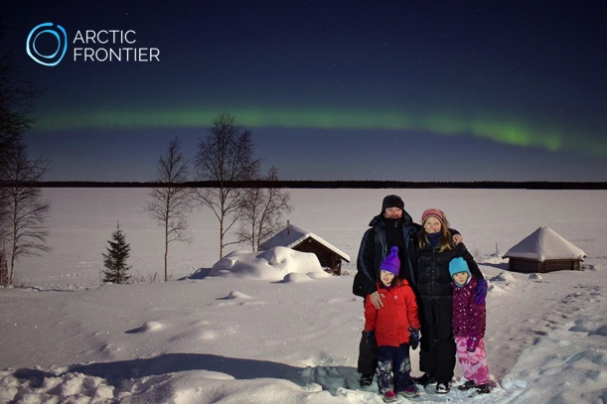 | Arctic Frontier provides access to:  Nikon SLR digital camera  Manfrotto tripod  Arctic overalls (adult)  Professional instruction  Warm and comfortable transport  Head torch  Chocolate brownies  Home-made berry juice
*The Chase can be extended past midnight if conditions are suitable. Alternative times are also available to coincide with the best aurora and weather forecasts.
** Like the weather, we have no control over the northern lights, and cannot guarantee their visibility. However, with our support and equipment your chances of an aurora encounter are increased significantly.

www.arcticfrontier.fi
mail@arcticfrontier.fi
+358 466 596443

