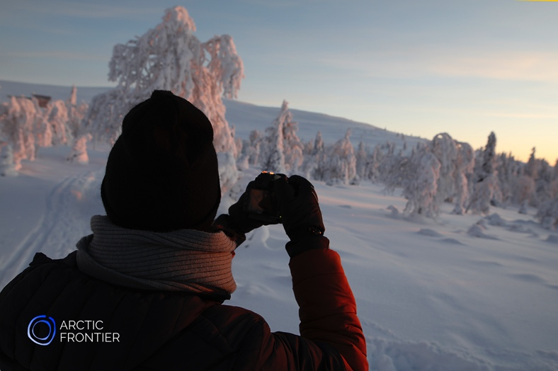

National Park Photography Tour – Private
with Arctic Frontier
December 2018 – April 2019
4 hours 11:00h-15:00h

Capture the magic of the Arctic! Your guided photography adventure will change the way you look at nature through the lens.

Join Arctic Frontier on a private tour into the heart of Pallas-Ylläs National Park. We tailor the tour to your photographic needs. Our local knowledge and expertise is perfect for those who want to take exceptional photographs of the breathtaking beauty of Lapland in safety and comfort.

Enjoy a delicious lunch made with ingredients from the forests and lakes where you will be exploring on your Photography Tour with Arctic Frontier.

Cameras and tripods are available, or bring your own. We provide snowshoes and winter boots so you can get to those places in the snow that you are unable to walk to.

Departure point and return: Your accommodation.
Price: 500€ for up to two people, additional 100€ per person.
Max. group size: 8

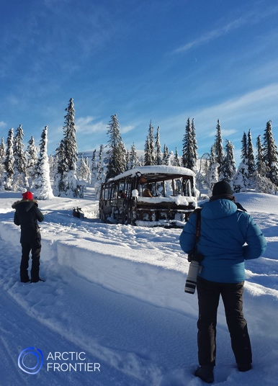 | Arctic Frontier provides you with:  Comfortable transport  Lunch & refreshments  Photography equipment if required  Winter boots  Snowshoes  Instruction is in English.

www.arcticfrontier.fi
mail@arcticfrontier.fi
+358 466 596443

