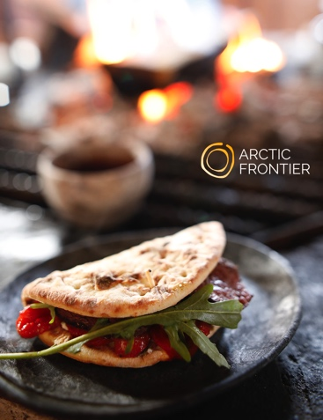

Snow, Fire & Feast with Arctic Frontier
Pallas-Yllästunturi National Park
December – April 2019
4 hours 10:00h – 14:00h

Imagine snow-covered trees, the silence of snowy white fells, enjoying local food by the fire and drinking fresh water from Arctic streams. Join Arctic Frontier on a guided tour of the local National Park, one of the best-kept secrets in Levi.

Discover the unique Arctic environment and delights of the Pallas-Yllästunturi National Park with us. We share our love of food and the places where we love to go with you.

Travel in comfort to the National Park, 45 minutes drive from Levi. Enjoy a short snowshoe (or walk) to a Lapland style hut and share a meal cooked by the fire using locally sourced and foraged ingredients, found in the places we are visiting.

Lunch includes unique Lapland breads, nettle seeds, lingonberries, cloudberries and juniper. Taste what lies beneath the snow! Special dietary needs can be easily accommodated, please contact us in advance.

Departure point and return: Zero Point, Levi.
Time: 10:00am to 2:00pm, duration 4 hours.
Price: 165€ adults and 90€ children (ages 15 – 4, children under 4 free)
Max. group size: 8 (suitable for all ages)

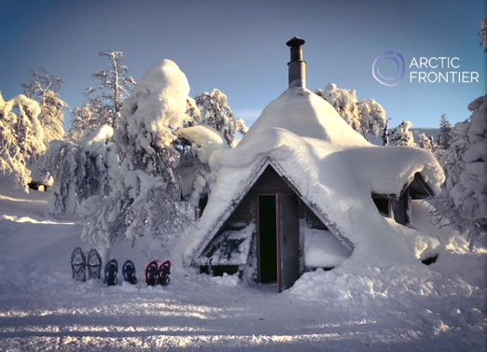 | Arctic Frontier provides you with:  Warm & confortable transport  Winter boots & Arctic overalls (adults)  Snow shoes  Lunch & chocolate brownies  Home-made berry juice  Instruction is in English

www.arcticfrontier.fi
mail@arcticfrontier.fi
+358 466 596443

