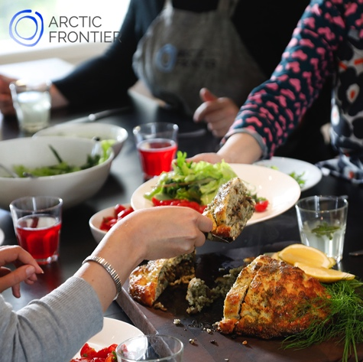

Wild Food Cooking Workshop with Arctic Frontier
December 2018 – April 2019
5 hours 10:00am – 3:00pm

Taste what lies underneath the snow and go wild with Arctic flavours on Arctic Frontier’s Wild Food Cooking Workshop!

Experiment with wild nettle seeds, combine local wild mushrooms with dark chocolate and more! Cook and share these delicious dishes around a dinner table in a log cabin on the edge of an Arctic lake next to the National Park.

Together, we prepare a four-course meal. All the ingredients, including special Arctic foods and equipment are included to make our feast. We take you to our lakeside Rauhala kitchen, 35 mins from Levi, in warmth and comfort.

All recipes include wild foods that have been picked around Levi. Growing in the cleanest air in Europe, collected ethically and sustainably.

We begin the workshop with entrees using smoked reindeer and nettle seeds. For our main meal we prepare a wild mushroom sauce with two different cuts of local reindeer. Will you taste the difference? The feast continues with desserts created from locally foraged berries and frozen outside in the snow!

Price: 180€ adults and 90€ children (under the age of 15)
Max. group size: 8 (suitable for all ages)
Duration: 5 hours
Departure point and return: Zero Point, Levi

Non-alcoholic wild food themed drinks are included. Please bring your own wine or beer to enjoy with your meal.

Special dietary needs can easily be accommodated. Please let us know in advance.

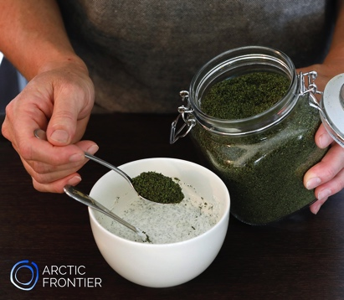 | Arctic Frontier provides you with:  Four-course meal & refreshments  Recipes we cook on the day  All ingredients & equipment  Warm and comfortable transport  Instruction is in English.

www.arcticfrontier.fi
mail@arcticfrontier.fi
+358 466 596443

