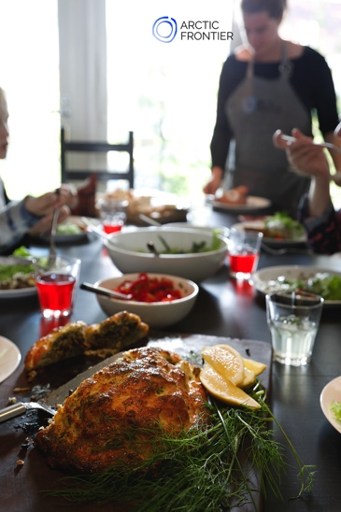

Exclusive Wild Food Cooking Workshop
with Arctic Frontier
2018 & 2019

Taste what lies underneath the snow and go wild with your friends and family with Arctic flavours on Arctic Frontier’s exclusive Wild Food Cooking Workshop.

Enjoy a private cooking workshop in your own cottage. We provide all the ingredients, including special Arctic foods and equipment, and together we prepare a four-course feast.

Experiment with wild nettle seeds, combine local wild mushrooms with dark chocolate and more! Cook and share these delicious dishes around your own dinner table with friends and family.

All recipes include wild food that has been picked around Levi. Growing in the cleanest air in Europe, collected ethically and sustainably.

We begin the workshop making entrees with smoked reindeer and nettle seeds. For our main meal we prepare a wild mushroom sauce with two different cuts of local reindeer. Will you taste the difference? The feast continues with desserts created from locally foraged berries and frozen outside in the snow!

Price: 160€ adults and 80€ children (under the age of 15. Children under 4 free)
Min. group size: 3 - Max. group size: 15 (suitable for all ages)
Duration: 3.5 hours
Please contact us to arrange a suitable time.

Non-alcoholic wild food themed drinks are included. Please supply your own wine or beer to enjoy with your meal.

Special dietary needs can easily be accommodated. Please let us know in advance.

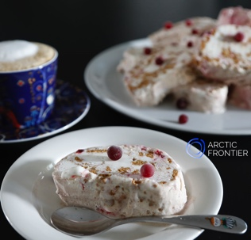 | Arctic Frontier provides you with:  Four-course meal & refreshments  Recipes we cook on the day  All ingredients & equipment  Instruction is in English.

.

www.arcticfrontier.fi
mail@arcticfrontier.fi
+358 466 596443

